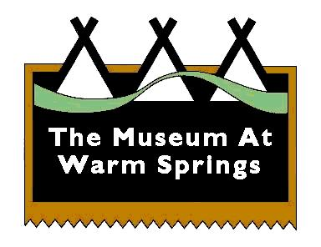
The Museum At Warm Springs
2189 Hwy 26 P.O. Box 909
Warm Springs, OR 97761

FOR IMMEDIATE RELEASE
Media Contact Only: Elizabeth Woody, Executive Director (541) 553-3331; maws@museumatwarmsprings.org

THE MUSEUM AT WARM SPRINGS WILL REOPEN TO THE PUBLIC
ON TUESDAY, SEPTEMBER 22

Strict Covid-19 and wildfire health and safety procedures will be in place
(WARM SPRINGS, Ore., Sept. 17, 2020) — In adherence to strict Covid-19 and fire, health and safety procedures, The Museum At Warm Springs will reopen to the public on Tuesday, September 22.
Throughout the Covid-19 pandemic, the Museum has been routinely and thoroughly cleaned and sanitized. The Museum has been following the guidelines for public facilities, which have been regularly updated and closely monitored by the Warm Springs Covid-19 Response team.
During the current wildfire situation and until further notice, The Confederated Tribes of Warm Springs Tribal Council will require all Museum visitors and staff to wear KN95 or N95 masks while in the Museum or on the Museum grounds. A number of other health procedures have already been established at the Museum during the Covid-19 pandemic, which are all designed to keep the public and Museum staff safe.
Admittance to the Museum’s main exhibition area will be limited to 10 people with no more than five in the gallery at one time. Visitation to the Museum Gift Shop will be limited to two people unless the visitors are in one car or unit.
“This has been an extremely challenging time for our Museum’s staff, and we are very much looking forward to once again opening our doors to the public,” said Museum Executive Director Elizabeth A. Woody (Warm Springs). “Our visitors can be assured that we are doing everything possible to ensure everyone has a safe and enjoyable time while they are here.”
The Museum’s new exhibition titled, “The Path of Resilience,” is currently on view through Saturday, September 26, 2020. Featured are beautifully beaded objects, woven treasures and various items selected from the Museum’s permanent collection and archives department.
For more information and updates, please visit www.museumatwarmsprings.org and the Museum’s Facebook page. To check the most up-to-date status of Covid-19 in Oregon, go to https://govstatus.egov.com/OR-OHA-COVID-19. For news and updates on Oregon wildfires, visit https://wildfire.oregon.gov/.
# # #

Note to Editors Only: Photographs, Courtesy The Museum At Warm Springs

