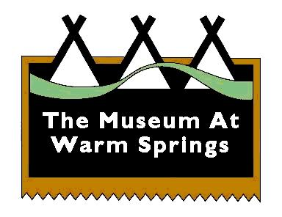
The Museum At Warm Springs
2189 Hwy 26 P.O. Box 909
Warm Springs, OR 97761

FOR IMMEDIATE RELEASE
Media Contact Only:
Sunmiet Maben; officemanager@museumatwarmsprings.org
Debbie Stacona; dstacona@museumatwarmsprings.org

THE MUSEUM AT WARM SPRINGS CLOSED TO PUBLIC
WEDNESDAY, NOVEMBER 18 THROUGH WEDNESDAY, DECEMBER 2
(WARM SPRINGS, Ore., Nov. 16, 2020) — In accordance with the Governor’s recent directive to slow the spread of Covid-19, The Museum At Warm Springs will be closed to the public from Wednesday, November 18 through Wednesday, December 2. The Museum will reopen on Thursday, December 3.
The Museum staff will respond to emails during the closure and will continue with exhibit and public and education program planning for 2021. Routine, thorough cleaning and sanitizing of the Museum will continue to take place. For the past several months of the pandemic, The Museum has been following the guidelines for public facilities, which have been regularly updated and closely monitored by the Warm Springs Covid-19 Response team.
Once the Museum reopens on Thursday, December 3, admittance to the main exhibition area will once again be limited to 10 people with no more than five in the gallery at one time. Visitation to the Museum Gift Shop will be limited to two people unless the visitors are in one car or unit.
The “27th Annual Tribal Member Exhibit” will be on view through January 9, 2021. This juried exhibit celebrates the artistic excellence of Warm Springs tribal members. Select artworks are available for sale. Sales support the artists and the Museum.
For more information and updates, please visit www.museumatwarmsprings.org and the Museum’s Facebook page. To check the most up-to-date status of Covid-19 in Oregon, go to https://govstatus.egov.com/OR-OHA-COVID-19.
# # #

